Research Techniques in Social Psychology
Psychologists use a number of different technical methods to conduct research on social psychology topics. These methods allow researchers to test hypotheses and theories and look for relationships between different variables.
Research in psychology is conducted in broad accord with the standards of the scientific method, encompassing both qualitative ethological and quantitative statistical modalities to generate and evaluate explanatory hypotheses with regard to psychological phenomena. Where research ethics and the state of development in a given research domain permits, investigation may be pursued by experimental protocols. Psychology tends to be eclectic, drawing on scientific knowledge from other fields to help explain and understand psychological phenomena.
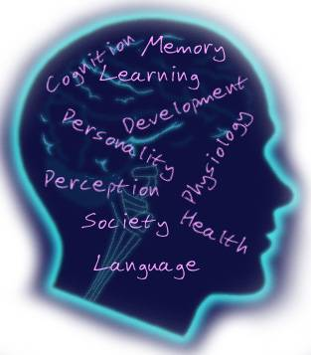
Qualitative psychological research utilizes a broad spectrum of observational methods, including action research, ethnography, exploratory statistics, structured interviews, and participant observation, to enable the gathering of rich information unattainable by classical experimentation. Research in humanistic psychology is more typically pursued by ethnographic, historical, and historiography methods.
Descriptive Research:
The goal of descriptive research is to portray what previously exists in a group or population. One model of this type of research would be an opinion poll to find which political candidate people plan to vote for in an upcoming election. Unlike causal and relational studies, graphic studies cannot determine if there is a relationship between two variables.
Correlational Research
Social psychologists use correlational research to look for interaction between variables. Conducting surveys, directly observing behaviors, or collect research from earlier studies is some of the methods used to gather data for correlational research. While this type of study can help determine if two variables have a relationship, it does not allow researchers to determine if one variable causes changes in another variable.

Experimental Research
Experimental research is the key to finding causal relationships between variables. In this research, the experimenter at random assigns participants to one of two groups: the control group and the experimental group. The control group receives no action and serves as a baseline. Researchers control the levels of some independent variable in the experimental group and then measure the effects. Because researchers are able to control the independent variables, experimental research can be used to find causal relationships between variables.
The testing of different aspects of psychological function is a significant area of contemporary psychology. Psychometric and statistical methods predominate, including various well-known standardized tests as well as those created ad hoc as the situation or experiment requires.
Academic psychologists may focus purely on research and psychological theory, aiming to further psychological understanding in a particular area, while other psychologists may work in applied psychology to deploy such knowledge for immediate and practical benefit. However, these approaches are not mutually exclusive and most psychologists will be involved in both researching and applying psychology at some point during their career.
Clinical psychology, among many of the various disciplines of psychology, aims at developing in practicing psychologist’s knowledge of and experience with research and experimental methods which they will continue to build up as well as employ as they treat individuals with psychological issues or use psychology to help others.
Quantitative psychology involves the application of statistical analysis to psychological research, and the development of novel statistical approaches for measuring and explaining human behavior. It is a young field (only recently have Ph.D. programs in quantitative psychology been formed), and it is loosely comprised of the subfields psychometrics and mathematical psychology.

